SPIRIT OF GARBO by MOON LARAMIE
New biograPhy of Greta Garbo reveals the unorthodox spiritual life of the Hollywood star.

Greta Garbo is often depicted as a tragic and lonely recluse. But there is another aspect to the mysterious star: she was a part-time and enthusiastic occultist, an independent spiritual explorer drawn to the ideas of eastern mysticism.

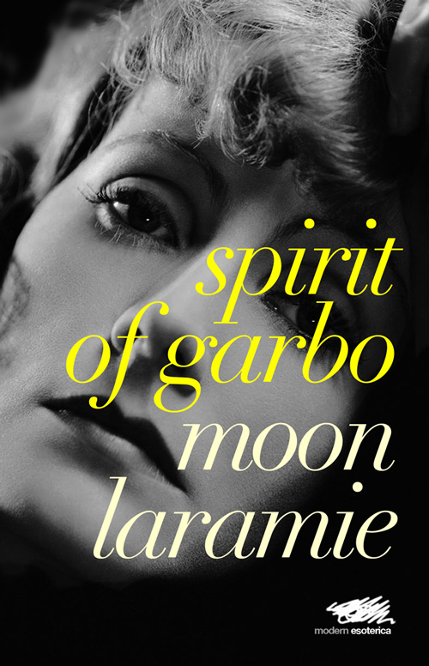
In Spirit of Garbo, Moon Laramie, explores the spiritual journey of Greta Garbo, her interest in unorthodox spiritual ideas, and her almost ‘pagan’ communion with nature and the cosmos.

Self-actualisation is the state of being fully realised as an individual, first described by the American psychologist Abraham Maslow in the 1950s. Moon Laramie maps the essential aspects of self-actualisation onto Garbo’s spiritual development. These aspects include a profound sense of self, a feeling of wonder and elation about the world, and an intense freedom of spirit.

Greta Garbo was attracted to eccentric people with a distinctly unconventional approach to life. These included the Spanish-American poet Mercedes de Acosta, the art dealer Sam Green and the conductor Leopold Stokowski. With their help, she explored the mystical ideas of reincarnation, astral travel and cosmic consciousness. This prompted the travel writer James Pope-Hennessy to describe Garbo as ‘interested in Theosophy, dieting and all other cranky subjects’. Mercedes de Acosta referred to her as ‘rather a crazy, mystic Swede’.

Moon Laramie argues that it was Garbo’s spiritual sense that enabled her to triumph over the studio system, remaining true to herself despite the pressure to conform from both Hollywood and wider society.

Spirit of Garbo by Moon Laramie is published on 17 September 2018 by Martin Firrell Company Ltd in original hardback and paperback editions.
Contact: nathalie@martinfirrell.com
Full details and downloadable press resources: http://martinfirrell.com/publishers/spirit-of-garbo

