SHAPES IN THE DARK by WILLIAM JACKSON

EIGHTEEN GAY HORROR STORIES WITH A TASTE OF THE GOLDEN AGE OF HAMMER HORROR, INTRODUCED BY CAROLINE MUNRO

'The writing is immensely visual, bewitching and erotic. What a heady mix of emotions!’ - CAROLINE MUNRO
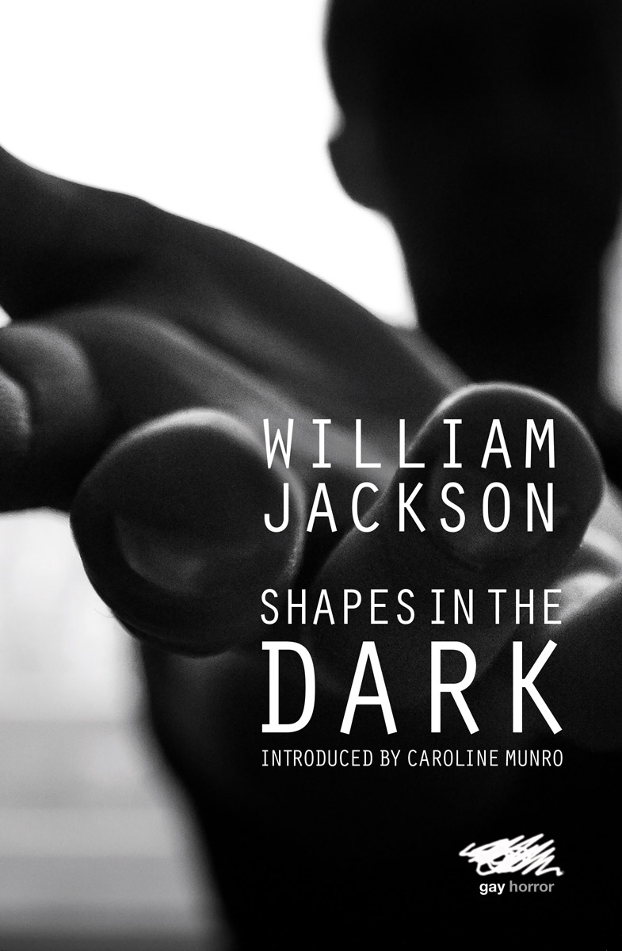
Shapes in the Dark is the debut collection of eighteen hauntingly gentle and spine-chilling LGBT horror stories by William Jackson.

With their deserted lanes and isolated cottages, wolfish men and vampire vixens, Jackson’s wicked tales have been described as 'Hammer Horror for the 21st Century'.

Fittingly, the collection is introduced by Hammer Horror and Bond star Caroline Munro.

In ‘Out of Water’, a lonely man befriends a beautiful boy who is not all that he seems. In 'My Funny Valentine’, a famous model and her lesbian vampire lover find themselves the victims of blackmail. And in ‘Forbidden’, a 1950s gay couple are targeted for execution.

Spanning the period from the 1950s to the present day, Shapes in the Dark takes the reader on a rollercoaster journey through a shadowy world of mermen, demon dogs, handsome werewolves, murderous gay couples, puritanical homophobes and mad scientists.

ABOUT WILLIAM JACKSON
William Jackson is the new master of gay horror, striking at the heart of the reader's deepest fears, then deftly twisting his pen. He cites his influences as Richard Laymon, Dennis Wheatley and Fred Mustard Stewart.

ABOUT CAROLINE MUNRO Caroline Munro is a British actress, model and singer known for her many appearances in horror, science fiction and action films of the 1970s and 1980s.

Shapes in the dark is published on 25 October 2021 in an original paperback edition by Martin Firrell Company.

More information and downloadable resources at www.moderneditions.net

Author’s website www.williamjackson.uk

Contact: Rupert Carrington, Publishing Executive, rupert@martinfirrell.com

